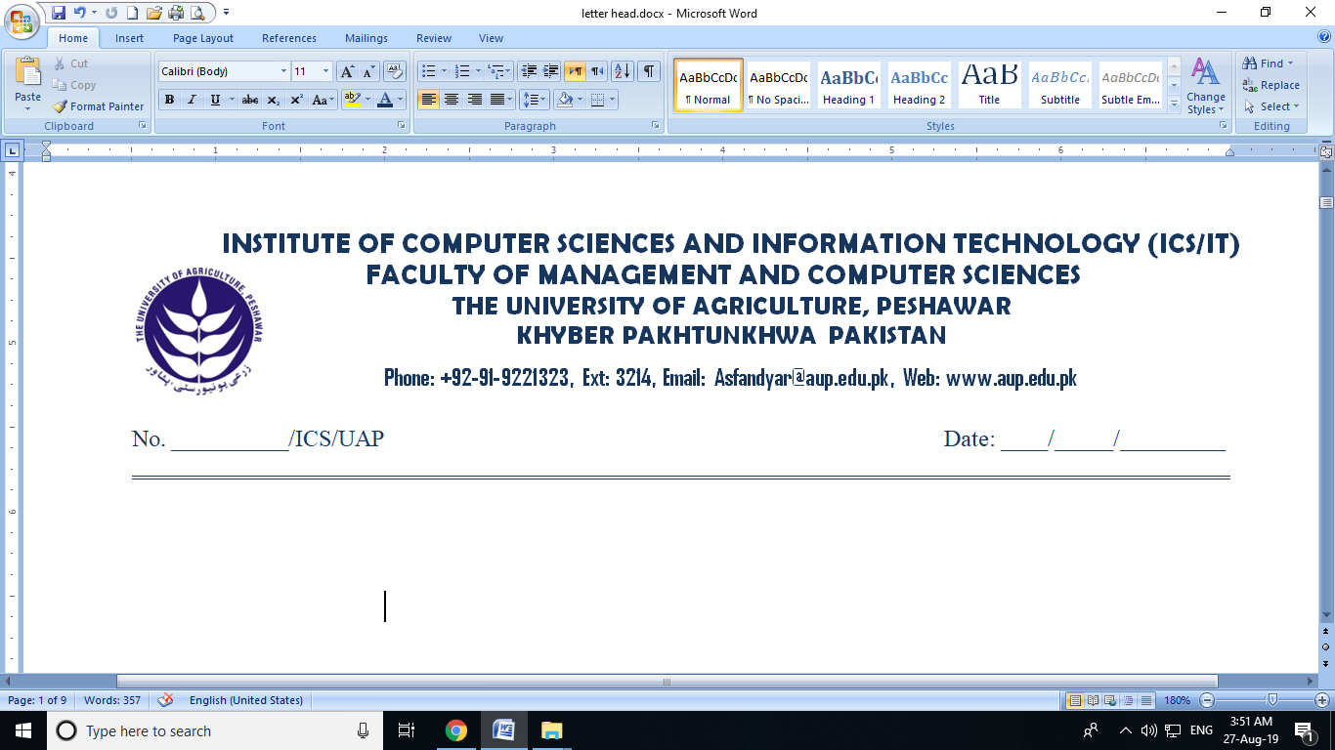

**BONAFIDE CERTIFICATE**

This is certified that **Mr. Miss______________________ S/D/O___________________** is / was a Regular student of **MS (CS-IT-DS)______** of this University for the session **20___-20___** under class roll no, **00____** and University Registration **No. ____-Agr-U-_______**.

**Incharge ICS/IT (FMCS)**

**Phone# 92-91-9221323**